**Why do you want to study your chosen major at Georgia Tech, and what opportunities at Georgia Tech will prepare you in that field after graduation?**

* 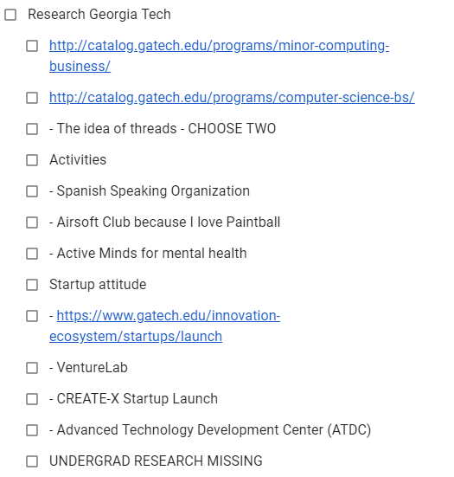
* While preparing for the Informatic Olympiads in my junior year of highschool I discovered an algorithm lecture series online. I binge watched them until I got stuck on an algorithm designed to uncover differences between texts. In trying to figure it out I came across an article on its application to analyzing DNA sequences of individuals from different species. I was fascinated by the application of this method across disciplines and challenged myself to do the same with the algorithms I was learning. That evening I had an epiphany; one of the topics that I was struggling most with was balancing complicated chemical equations. I wrote a program that applied classic computer science to the balancing problem. I started using it in class and shared it with a few friends, who thought it was tremendously useful.

Since that day, I step back at every opportunity and ask myself how what I am studying connects to what I know about computer science and this connection changes my understanding of the problem.

# Rev. 1

Programming is not about coding, it’s about problem solving. One learns to recognize and understand the trade-offs between several solutions to a problem and is able to judge which solutions best fits the case. After years of creating applications for fun and profit, I’ve realized that Computer Science is the major I love.

Since I found out algorithms could be used to better understand and develop other areas of knowledge, I’ve been excited about mixing Computer Science with other disciplines, such as biology and chemistry. The course on Computing Concepts for Bioinformatics caught my eye, as it allows me to study exactly what I want. Moreover, the idea of threads in the major, allows me to concentrate on more practical areas.

Furthermore, I want to take ideas to market, to generate real life impact. This is why I’d be interested in choosing the Minor in Computing and Business. I believe it will be a tremendous opportunity to gain the knowledge required to be able to take ideas to market.

I’ve had the experience of trying to raise a startup from the ground, and realize how difficult it is. I believe the Innovation Ecosystem, and specifically the CREATE-X Startup Launch will help me in this regard.

Besides my academic and entrepreneurial desires, I want to have a healthy mental state both during college and after graduation. That’s why I wish to be an active member of the Active Minds club.

\\

Inaki: el primer parrafo no tiene ninguna conexion con el segundo. Mas vale usar lo que escribiste antes, es mas interesante y esta mejor escrito.

# Rev. 2

* Un programa: Program
* Un profesor
* Un centro:
* Emprendedurismo
* Un testimonial de emprendedurismo

Years ago, while preparing for the Informatics Olympiads, I came across an article about the application of a text manipulation algorithm for analyzing DNA sequences of individuals from different species. I was fascinated by the application of this method across disciplines and challenged myself to do the same with the algorithms I was learning.

Later, through the development of various projects, such as a chemical equation balancer and a patient management program, I developed an interest in biochemistry and medicine. Georgia Tech’s Petit Undergraduate Research Scholars program offers an incredible opportunity to mix my two passions, CS and biochemistry. I want to work alongside the likes of Itsik Pe'er, who works on how changes to DNA sequencing affect biological processes.

Moreover, I am excited by the opportunity to intern at the Petit Institute for Bioengineering and Bioscience. With everything I learn from these opportunities I want to start a company that generates a positive social impact. Georgia Tech can provide me with the tools necessary to achieve this through its robust entrepreneurship program. I’d like to participate especially in the CREATE-X Startup Launch.

One of the examples of this support that encouraged me was the launch of Droice, the Columbia born drug analysis company that went from idea to production in twelve months through the participation in the Columbia Venture Competition, in which I hope to compete.

REV FINAL (G)

Two years ago, while preparing for the Informatics Olympiads, I came across an article about the application of a text manipulation algorithm for analyzing DNA sequences of individuals from different species. I was fascinated by the application of this method across disciplines and challenged myself to do the same with the algorithms I was learning.

In the past few years I have created several programs, but its was through the development of a navigation app for the blind community and a health reimbursement platform for people with disabilities that I developed a passion for applying computer science to health for the benefit of society.

Georgia Tech’s Computer Science Modeling & Simulations thread offers and incredible opportunity to combine CS with other areas of knowledge, including biology and chemistry. The Department of Biomedical Engineering program will let me study in depth the relationship between medical solutions and engineering. I hope to intern with researchers like Dr. Woon-Hong Yeo to work on unobtrusive brain-machine interfaces.

I’m also excited by the opportunity to conduct independent research in the Petit Institute for Bioengineering and Bioscience through its Undergraduate Research Scholars program.

Georgia Tech can provide me with the tools necessary to become an entrepreneur working on socially-minded tech through the Innovation & Entrepreneurship program. As part of this, I would like to participate in CREATE-X Startup Launch.